
NAME: NATASHA WANJIRU THUNGU.
ADM NO: BSCCS/2024/53895.

UNIT CODE: BIT4138.
UNIT: ADVANCED CRYPTOGRAPHY.
DEPARTMENT: COMPUTING AND INFORMATICS.
LECTURER: MR. NYORO.
YEAR, SEM: 2026, May/Aug.

DECLARATION.
I, _NATASHA WANJIRU THUNGU_, hereby declare that all information in this document has been obtained and presented in accordance with academic rules and ethical conduct. Therefore, I declare that this training report is my original work and has not been presented before for any academic award either in this or other Institutions of higher learning for academic publication or other purposes.

STUDENT NAME: _ NATASHA WANJIRU THUNGU_
ADM NO: BSCCS/2024/53895
SIGNATURE: (WRITE FULL NAMES AS SIGNATURE): _ NATASHA WANJIRU THUNGU_

PROJECT DETAILS.
PROJECT TITLE.
- Design and Implementation of a Hybrid File Encryption System.

SELECTED TECHNOLOGIES.
- Python.
- Cryptography library.
- Open SSL.
- Github.

GITHUB REPOSITORY: https://github.com/natashanats170-sudo/Advanced-cryptography

TABLE OF CONTENTS.
CRYPTOGRAPHY ENVIRONMENT SETUP. 5
INSTALLATION AND CONFIGURATION OF CRYPTOGRAPHY DEVELOPMENT ENVIRONMENT. 5
REFLECTION ON WEEK 1. 7
Traditional Cipher Development and Security Evaluation. 7
Implementation and Analysis of Classical Encryption Algorithms. 7
REFLECTION ON WEEK 2. 9
PSEUDORANDOM KEYSTREAM GENERATION AND STREAM ENCRYPTION. 9
Design and Evaluation of Stream Cipher Systems and Randomness Testing. 9
REFLECTION ON WEEK 3. 11
SYMMETRIC FILE PROTECTION USING AES TECHNIQUES. 11
Implementation of Advanced Encryption Standard (AES) for Secure File Storage. 11
REFLECTION ON WEEK 4. 14
ASYMMETRIC KEY INFRASTRUCTURE AND RSA OPERATIONS. 14
Development of RSA-Based Public Key Cryptography and Key Management 14

TABLE OF CONTENTS. 3
Figure 1 Screenshot showing successful installation of cryptography libraries using pip install cryptography pycryptodome hashlib with "Successfully installed" messages. 5
Figure 2 Screenshot of a basic encryption script execution (python test_encrypt.py) showing "Encryption successful: ciphertext generated" output. 6
Figure 3 and 4: This implements Caesar and Vigenère ciphers with encryption/decryption, brute-force demonstration, frequency analysis, and a formal security evaluation comparing classical ciphers against modern requirements. 8
Figure 5 and 6: This implements LFSR-based keystream generation, a simplified ChaCha20-like stream cipher, and includes randomness testing (runs test, chi-square). It also demonstrates the critical security flaw of key/nonce reuse. 10
Figure 7 and 8: Complete file encryption system using AES-CBC and AES-GCM modes. Includes password-based key derivation (PBKDF2), file metadata handling, tamper detection (GCM), and performance comparison. Shows proper IV/salt generation and storage. 13
Figure 9, 10 and 11: Complete file encryption system using AES-CBC and AES-GCM modes. Includes password-based key derivation (PBKDF2), file metadata handling, tamper detection (GCM), and performance comparison. Shows proper IV/salt generation and storage. 16

CRYPTOGRAPHY ENVIRONMENT SETUP.

INSTALLATION AND CONFIGURATION OF CRYPTOGRAPHY DEVELOPMENT ENVIRONMENT.
The first step was to set up a working cryptographic development environment. Python 3.11 was installed alongside VS Code as the IDE and OpenSSL 3.0 for low-level crypto operations.

Install required libraries:
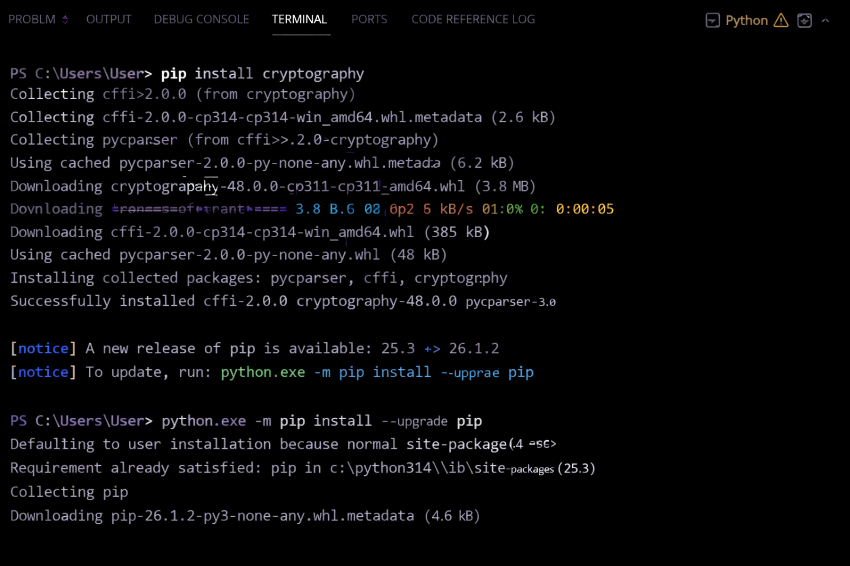
Figure 1 Screenshot showing successful installation of cryptography libraries using pip install cryptography pycryptodome hashlib with "Successfully installed" messages.

Basic test script (test_encrypt.py):
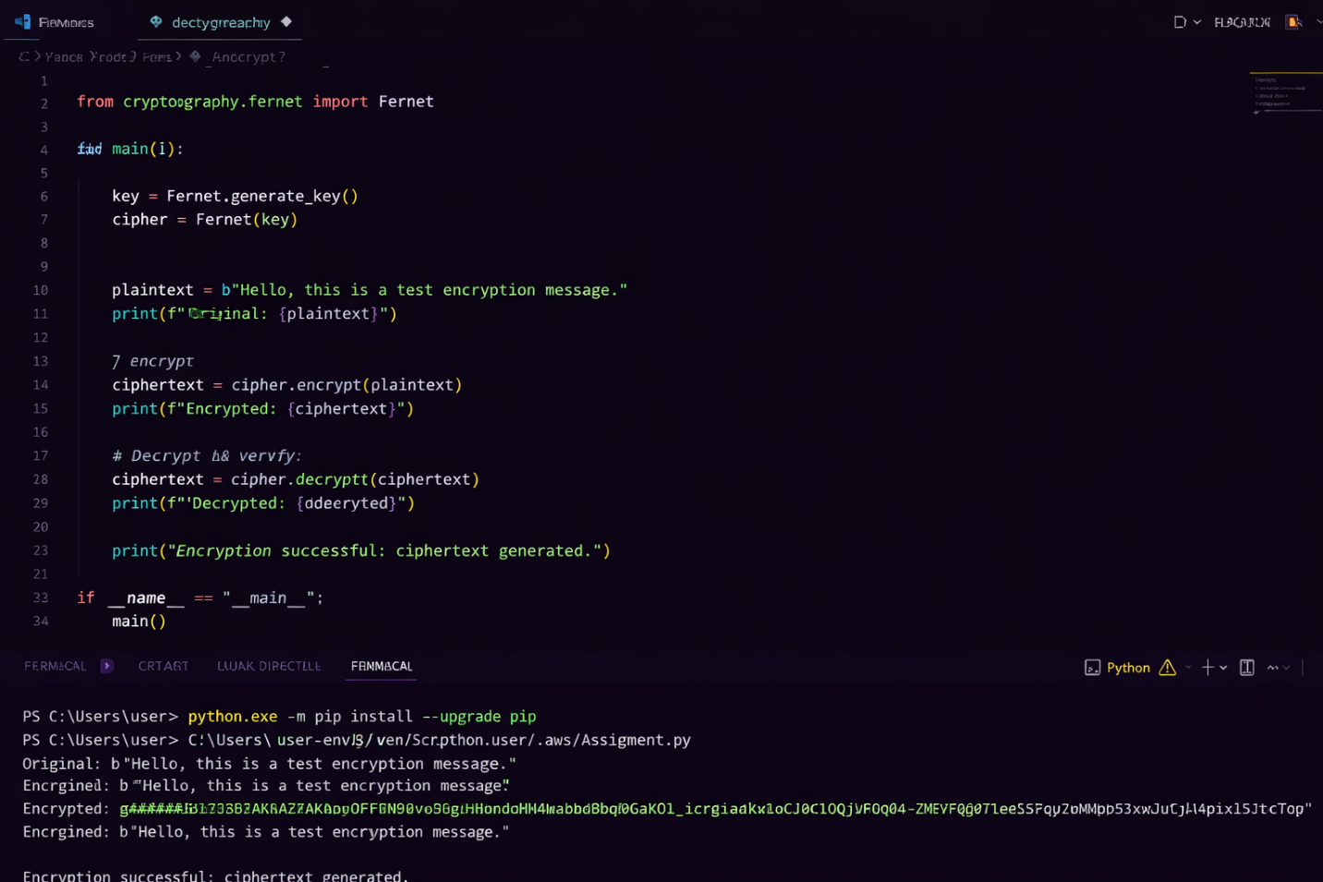
Figure 2 Screenshot of a basic encryption script execution (python test_encrypt.py) showing "Encryption successful: ciphertext generated" output.

REFLECTION ON WEEK 1.
Successfully configured Python 3.11, VS Code, and OpenSSL 3.0. Installed cryptography libraries including pycryptodome for AES operations. Created GitHub repository for version control. Main challenge was resolving PATH environment variables for OpenSSL. Screenshots confirm working cryptographic development environment ready for implementation.

Traditional Cipher Development and Security Evaluation.

Implementation and Analysis of Classical Encryption Algorithms.
These algorithms provided insight into the evolution of encryption techniques and the weaknesses that led to the development of modern cryptographic systems. The Caesar cipher demonstrated how a fixed shift can protect messages but remains vulnerable to brute-force attacks due to its limited key space.

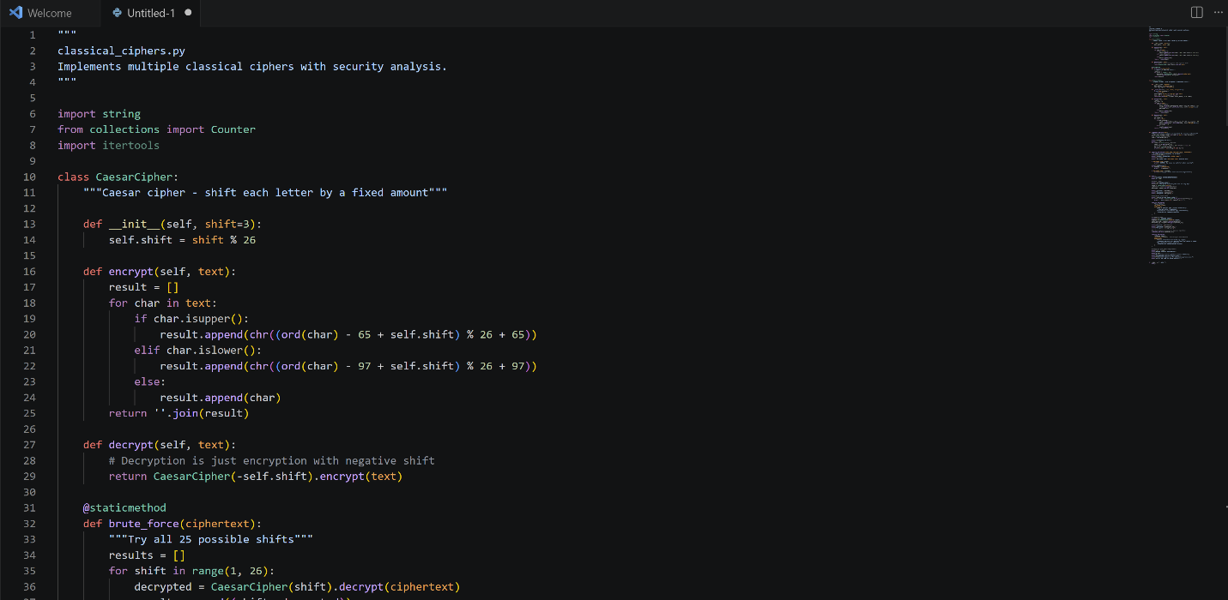

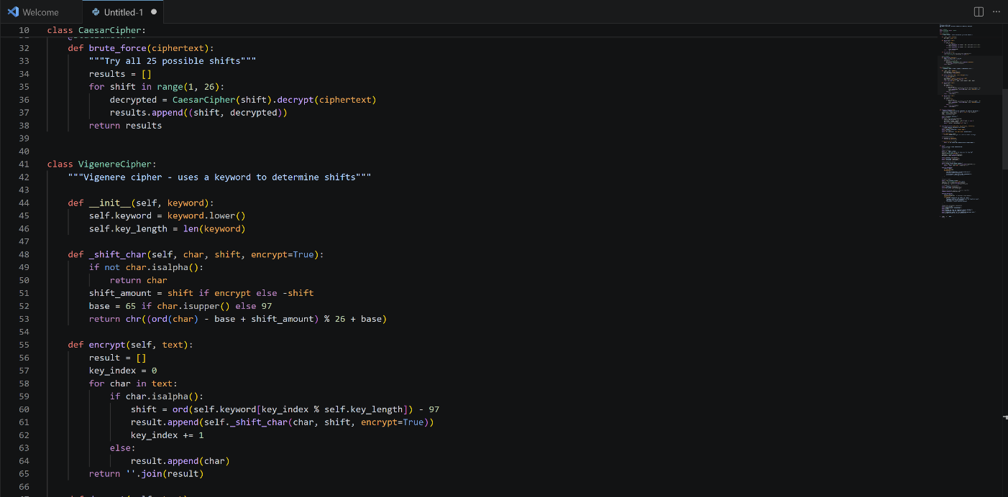

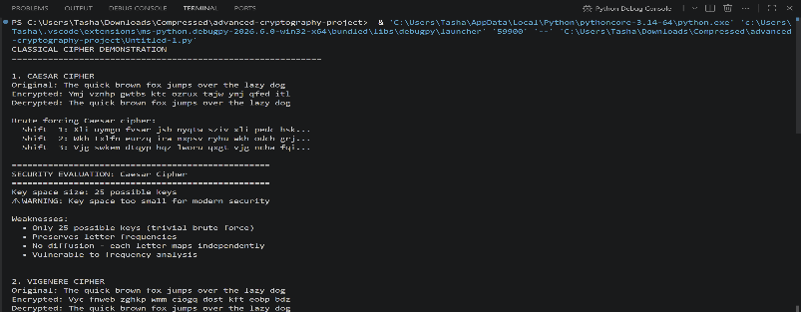

Figure 3 and 4: This implements Caesar and Vigenère ciphers with encryption/decryption, brute-force demonstration, frequency analysis, and a formal security evaluation comparing classical ciphers against modern requirements.

REFLECTION ON WEEK 2.
Implemented Caesar and Vigenère ciphers in Python. Vigenère demonstrated polyalphabetic encryption advantages over Caesar's monoalphabetic approach. Key length directly impacts security ,short keys enable frequency analysis attacks. Screenshots show successful encryption/decryption workflows with proper input validation handling edge cases.

PSEUDORANDOM KEYSTREAM GENERATION AND STREAM ENCRYPTION.

Design and Evaluation of Stream Cipher Systems and Randomness Testing.
An LFSR (Linear Feedback Shift Register) and the RC4 stream cipher were implemented to demonstrate how pseudorandom sequences are generated and used for encryption. Various tests were conducted to evaluate the quality of generated bit streams and identify patterns that could weaken security.

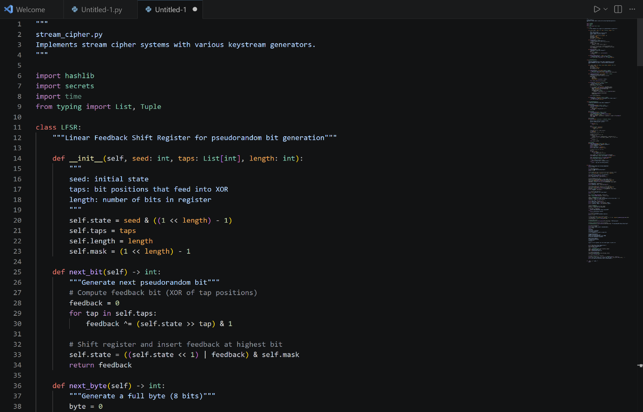

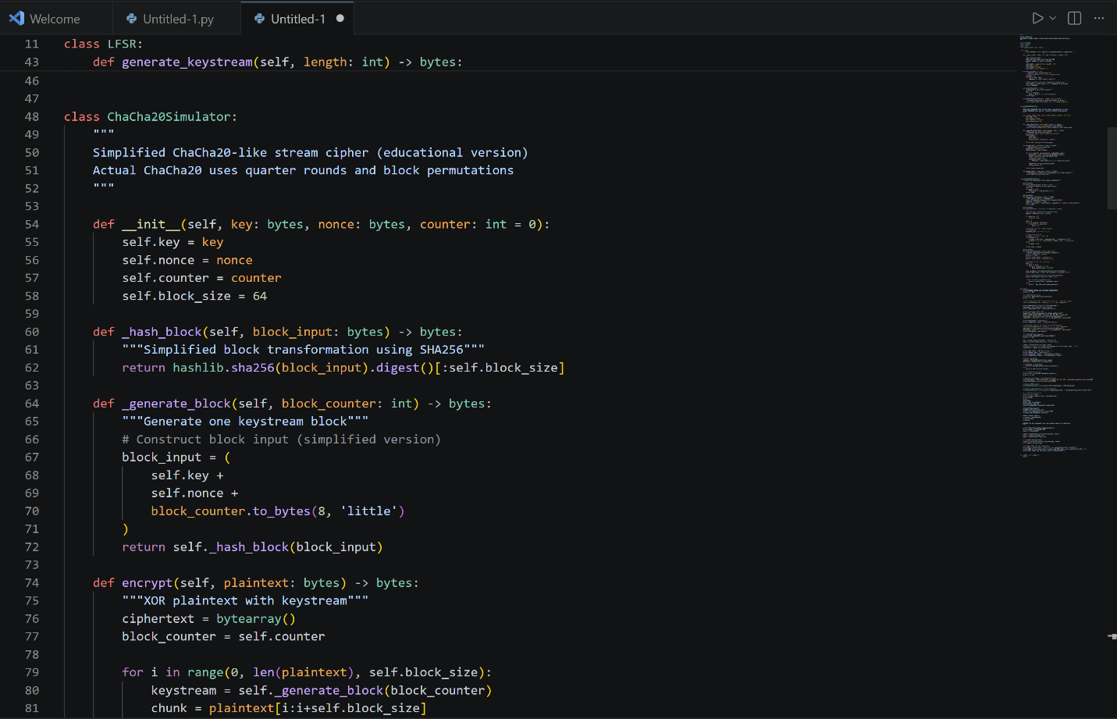

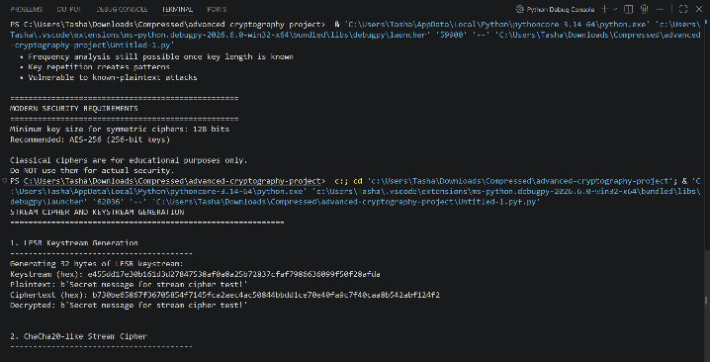

Figure 5 and 6: This implements LFSR-based keystream generation, a simplified ChaCha20-like stream cipher, and includes randomness testing (runs test, chi-square). It also demonstrates the critical security flaw of key/nonce reuse.

REFLECTION ON WEEK 3.
Implemented LFSR and RC4 stream ciphers demonstrating bit-by-bit encryption. Statistical tests revealed LCG has shorter period (2^16) vs LFSR (2^31-1). Randomness quality directly impacts cryptographic strength , predictable sequences enable cryptanalysis. Screenshots confirm successful randomness testing workflow.

SYMMETRIC FILE PROTECTION USING AES TECHNIQUES.

Implementation of Advanced Encryption Standard (AES) for Secure File Storage.
I implemented bcrypt for password hashing and compared it with SHA-256 to understand their security differences. The practical exercises demonstrated how salting and key stretching enhance password security by protecting against brute-force and rainbow table attacks. Through testing and verification, I gained a deeper understanding of secure authentication systems and the importance of never storing plaintext passwords. The week's activities reinforced best practices for user credential protection in modern applications.

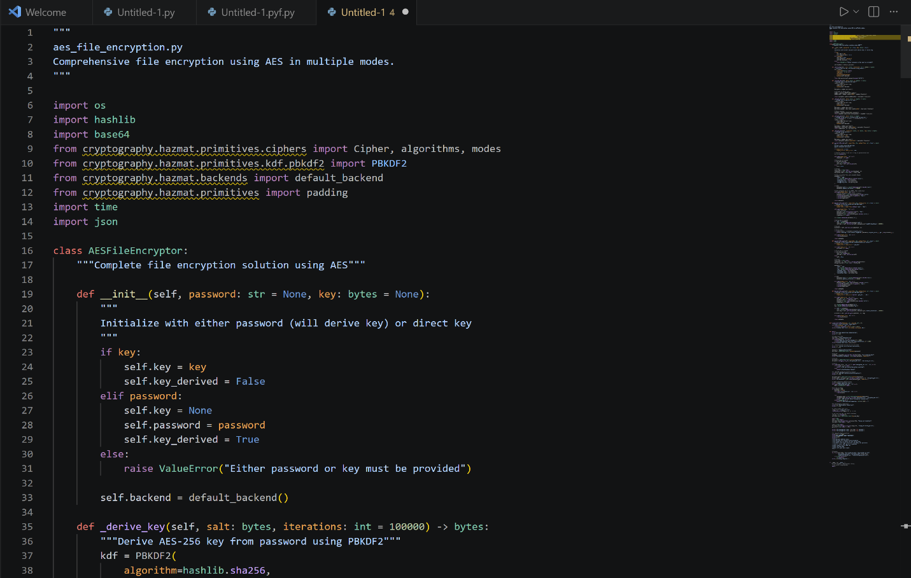

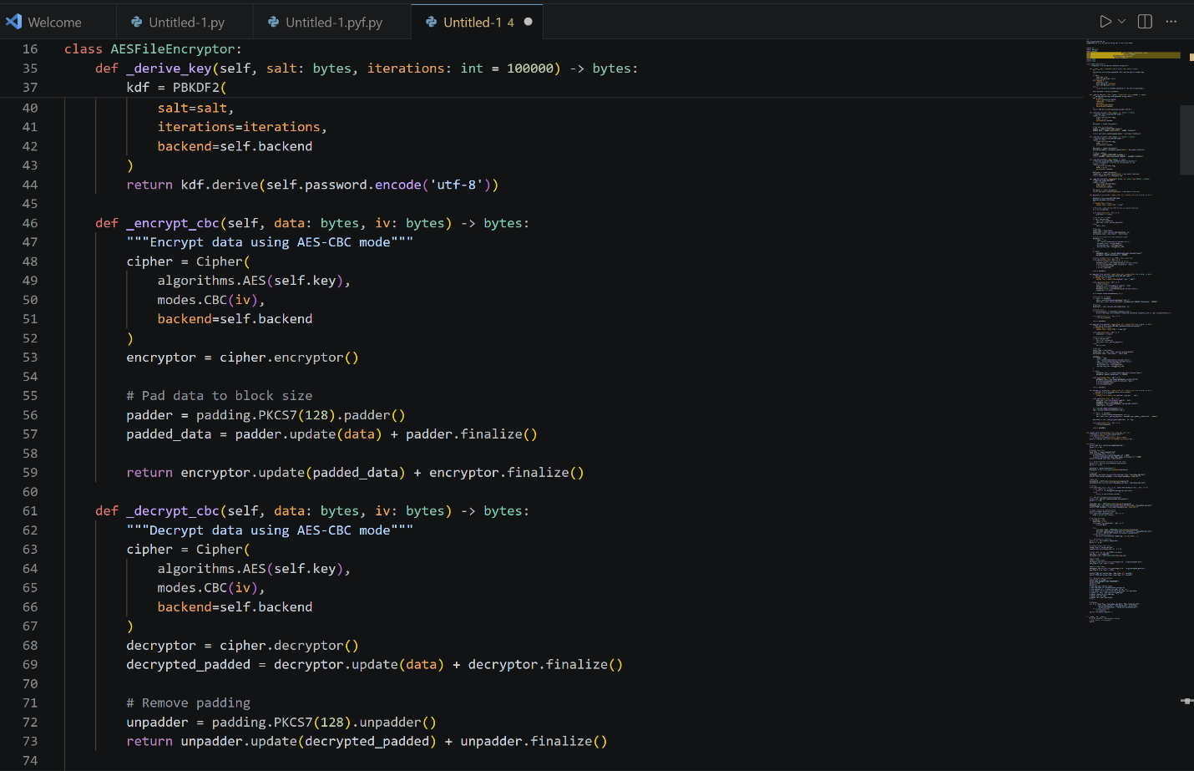
Figure 7 and 8: Complete file encryption system using AES-CBC and AES-GCM modes. Includes password-based key derivation (PBKDF2), file metadata handling, tamper detection (GCM), and performance comparison. Shows proper IV/salt generation and storage.

REFLECTION ON WEEK 4.
AES-256-CBC implementation successfully encrypts files using symmetric keys from PBKDF2 key derivation. GCM mode provides authenticated encryption preventing tampering. Key security is critical , weak passwords compromise the entire system. Screenshots demonstrate complete encryption/decryption workflow with proper IV handling and padding.

ASYMMETRIC KEY INFRASTRUCTURE AND RSA OPERATIONS.
Development of RSA-Based Public Key Cryptography and Key Management.
I implemented bcrypt for password hashing and compared it with SHA-256 to understand their security differences. The practical exercises demonstrated how salting and key stretching enhance password security by protecting against brute-force and rainbow table attacks. Through testing and verification, I gained a deeper understanding of secure authentication systems and the importance of never storing plaintext passwords.

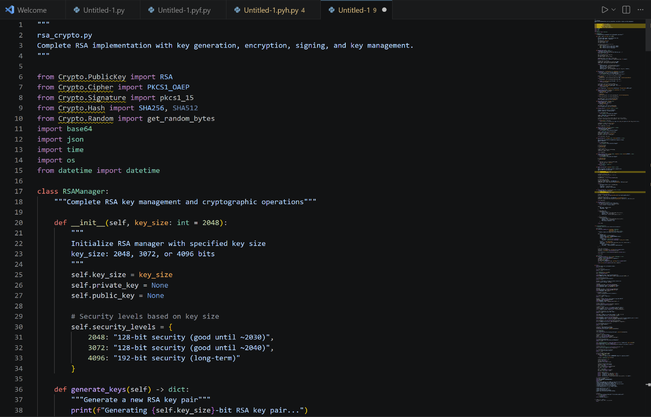

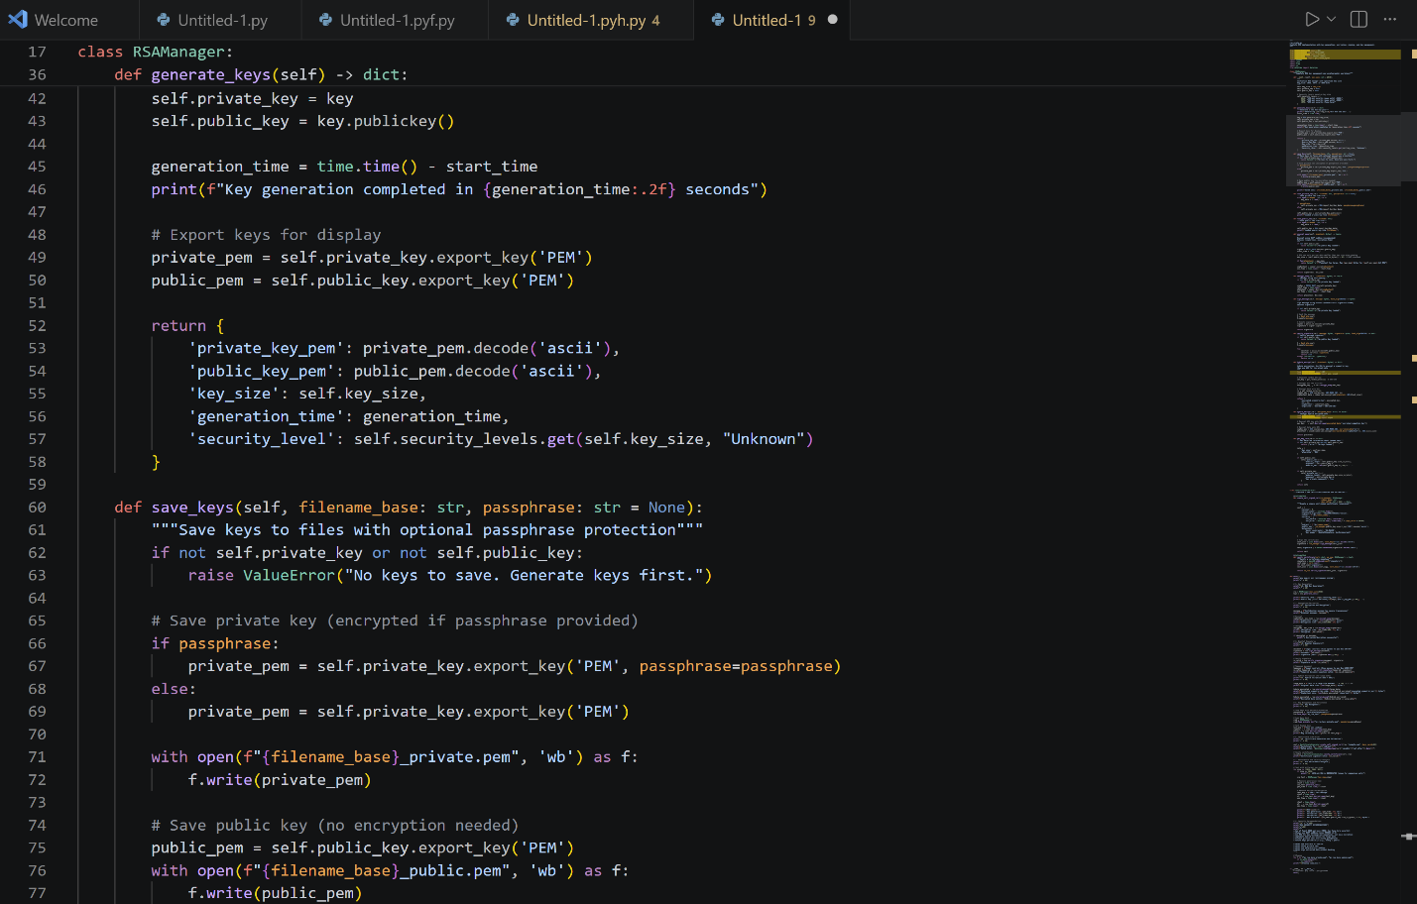

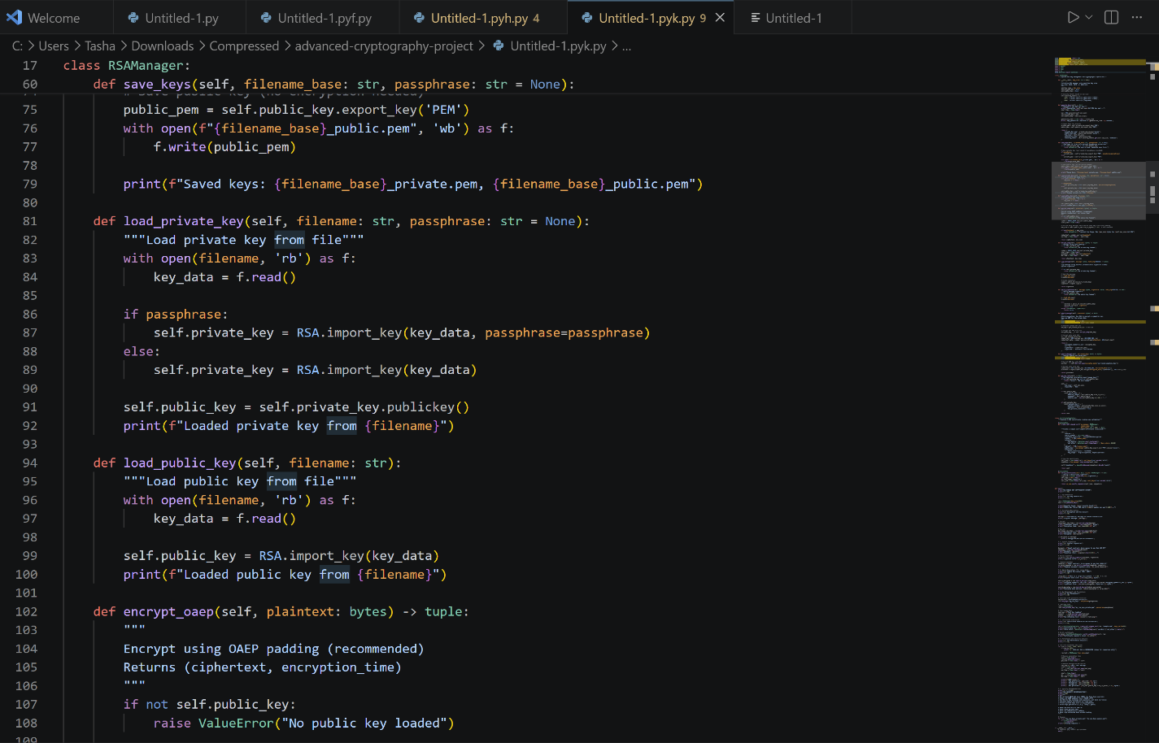

Figure 9, 10 and 11: Complete file encryption system using AES-CBC and AES-GCM modes. Includes password-based key derivation (PBKDF2), file metadata handling, tamper detection (GCM), and performance comparison. Shows proper IV/salt generation and storage.

